

**MATHEMATICAL METHODS**

**Units 3&4 – 2017**

**Written examination 2 Solutions**

**SECTION A**

|  |  |  |
| --- | --- | --- |
| **Question** | **Answer** | **Solution** |
| **1** | **A** | The period of a sine function is , where . |
| **2** | **D** | The range of the function *f* (*x*) = *x* – 5 is [−8, 3).  When *y* = − 8, − 8 = *x* – 5 ⇒ *x* = − 3 (closed interval)  When *y* = 3, 3 = *x* – 5 ⇒ *x* = 8 (open interval)  Domain *D* = [− 3, 8) |
| **3** | **C** | *f* (*x*) = *x* + 1 ⇒ *f* (−*f* (*x*)) = [− (*x* + 1)] + 1  = − *x* − 1 + 1  = − *x* … true  *f* (*x*) = *x* ⇒ *f* (−*f* (*x*)) = (− *x*)  = − *x* … true  *f* (*x*) = *x*3 ⇒ *f* (−*f* (*x*)) = (− *x*3)3  = − *x*9 ≠ − *x*  *f* (*x*) = *e*− *x*⇒ *f* (−*f* (*x*))  ≠ − *x*  *f* (*x*) = *x* − 1 ⇒ *f* (−*f* (*x*)) = − (*x* − 1) − 1  = − *x* + 1 − 1  = − *x* … true |
| **4** | **B** | *x*′ = *x* – 1 ⇒ *x* = *x*′ + 1  *y*′ = – 2*y* + 3 ⇒  Substitute the new coordinates into equation .  … multiply the equation by (−2)  − 4(*x* + 1) + *y* – 3 = −1 … expand the brackets |

|  |  |  |
| --- | --- | --- |
|  |  | − 4*x* − 4 + *y* – 3 = −1 … simplify  − 4*x* + *y* = −1 + 7  − 4*x* + *y* = 6  4*x* − *y* = − 6 |
| **5** | **A** | If *P*(2, – 7) is translated three units left, *P*1(– 1, – 7).  If *P*1(– 1, – 7) is dilated by a factor of five from the *y* – axis, *P*2(– 5, – 7). |
| **6** | **E** | For independent events, Pr(*A* ∪ *B*) = Pr(*A*) + Pr(*B*) – Pr(*A*) × Pr(*B*).  Pr(*A*) = 1 – 0.4 = 0.6, Pr(*B*) = *k*  Pr(*A* ∪ *B*) = 0.6 + *k* – 0.6*k*  = 0.6 + 0.4*k* |
| **7** | **B** |  |
| **8** | **D** | If (*x* – *p*) is a factor of *P*(*x*) = (3*p* + 1)*x*3 – 31*x*2 + *x* + 2*p*, then *P*(*p*) = 0.  3*p*4 + *p*3 – 31*p*2 + 3*p* = 0 … solve for *p*  Using available CAS technology, solve(3*p*4 + *p*3 – 31*p*2 + 3*p* = 0, *p*).  Solutions:  Since *p* is a positive real integer, *p* = 3. |
| **9** | **E** | For infinitely many solutions, the two lines are coincidental.  The ratios between corresponding coefficients are equal.    From the first two fractions, *k*2 – *k* = 12.  **Note**: Any two fractions could be used.  Solve *k*2 – *k* – 12 = 0 for *k* either using available CAS technology or by hand.  (*k* + 3)(*k* – 4) = 0 ⇒ *k* = –3 or *k* = 4  Check both *k* = –3 and *k* = 4.  When *k* = –3,  ⇒  When *k* = 4,  ⇒  ⇒  … true  ∴ *k* = 4 |

|  |  |  |
| --- | --- | --- |
| **10** | **C** | From 1 to 7 there are 3 even numbers (2, 4, 6) and 4 odd numbers (1, 3, 5, 7). |
| **11** | **A** | Confidence intervals: , where , *n* = 148 and *z* for the 95% confidence intervals is 1.96. |
| **12** | **B** | Let *y* = log*e*(*kx*)    The equation of the tangent is .  When *x* = *p* = 2, .  The point of tangency has coordinates (2, 0).  When *x* = *p* = 2, .  *p* = 2 and |
| **13** | **E** | The graph of *f* (*x*) is shown below.  The domain of the inverse function *f*−1(*x*) is [−3, 3].    The minimum positive value of *a* and the maximum positive value of *b* for which *f* (*x*) has an inverse are *a* =. |

|  |  |  |
| --- | --- | --- |
| **14** | **D** | *p* = Pr(correct serve) =  and *n* = 75  mean = *np*  = 75 × 0.88  = 66 |
| **15** | **E** | Using available CAS technology, solve  *a* =  Since *a* > 0, discard the negative values.  Since *a* is an integer, discard . ∴ *a* = 1 |
| **16** | **A** | **Option A**  Pr(*D* ∩ *L*′) = 0.35 × 0.8  = 0.28 ≠ 0.44  **Option B**  Pr(*L*) = Pr(*L*|*D*) + Pr(*L*|*D*’)  = 0.35 × 0.2 + 0.65 × 0.24  = 0.226 … true  **Option C**  Pr(*D*′) = 1 – Pr(*D*)  = 1 – 0.35  = 0.65 … true  **Option D**    **Option E**  Pr(*D*′ ∩ *L*′) = 0.65 × 0.76  = 0.494 … true  **Alternatively**, a tree diagram could be used. |
| **17** | **D** | Area of the parallelogram = 2 × Area of triangle *BCD*  = 2 ×  ⇒ *A*parallelogram = *ab*sin(*x*)  The derivative of the area, *A*′ = *ab*cos(*x*)  For maximum area, *A*′ = 0.  *Ab*cos(*x*) = 0 ⇒ cos(*x*) = 0∴  Since 0 < *x* < *π*,  for maximum area |

|  |  |  |
| --- | --- | --- |
| **18** | **E** | Using available CAS technology, calculate normCdf(3.7, 6.4, 5.2, 1.2) = 0.7357.  Pr(3.7 < *x* < 6.4) = 0.7357 |
| **19** | **B** | Area 1 =  Area 2 =  Area 1 – Area 2 =  =  = |
| **20** | **A** | *f* (*x*) is strictly increasing when *f* ′(*x*) > 0 ⇒ *x* ∈(−1, ∞)\{1, 4} |

**SECTION B**

**Question 1** (8 marks)

**a.**

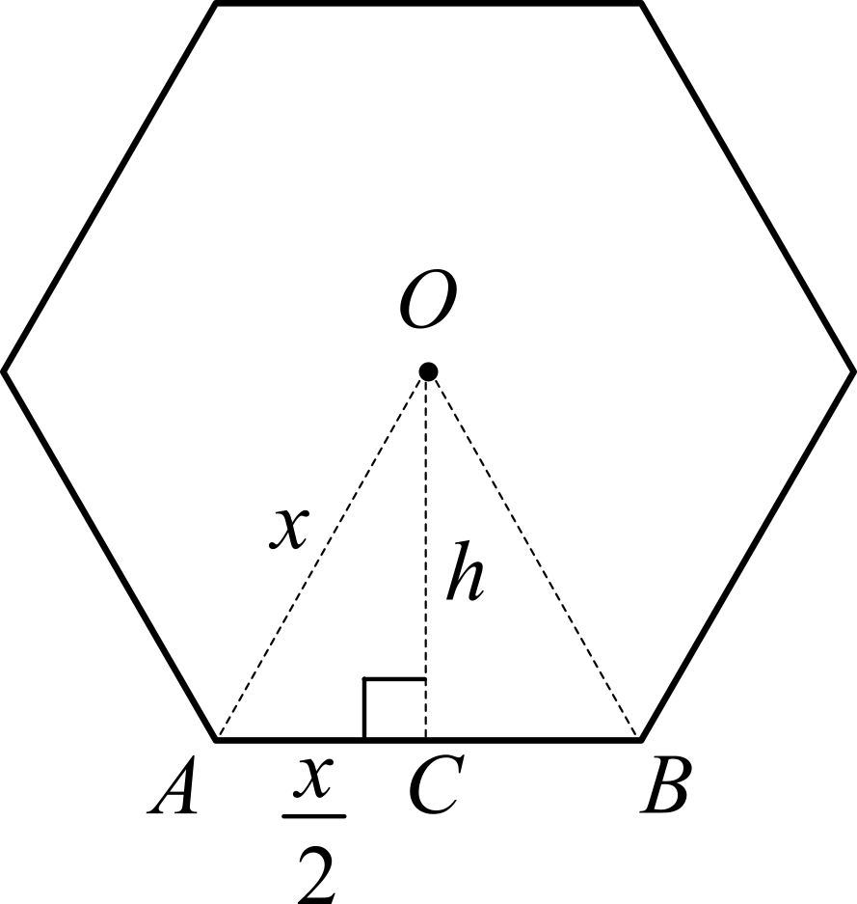

Δ*OAB* is an equilateral triangle and Δ*OAC* is a right-angled triangle with .

Using Pythagoras theorem, 

 **1M**

**b.** 

 **1A**

 **1A**

**c.** *V* = Areahexagon × height

 **1A**

**d.** 19 – *x* > 0

– *x* > – 19 ⇒ *x* < 19

Also *x* > 0 ⇒ *x* ∈ (0, 19) **1A**

**e.** 

Maximum volume occurs when  ⇒ 38*x* – 3*x*2 = 0 **1M**

*x*(38 – 3*x*) = 0

*x* = 0 or 

Discard *x* = 0 since it is not an element of the domain ⇒  **1A**

**f.** *H* = 19 – *x*

For maximum volume, .

 **1A**

**Question 2** (10 marks)

**a.** Let *X* be the random variable weight of a medium gift box.

Using available CAS technology, Pr(*X* ≥ 274) = normCdf(, ∞, 0, 1) **1M**

= normCdf( , ∞, 0, 1)

= 0.88918 ≈ 0.8892 **1A**

**b.** Let *Y* be the random variable weight of a large gift box.

Using available CAS technology, Pr(393 ≤ *Y* ≤ 426) = normCdf(, , 0, 1) **1M**

= normCdf(−0.8, 1.4, 0, 1)

= 0.70738 ≈ 0.7074 **1A**

**c. i.** Sample proportion medium gift boxes = 0.60

Number of medium gift boxes = 0.60 × 30

= 18 **1A**

**ii.** Sample proportion large gift boxes =  **1A**

Using available CAS technology, calculate binomPdf(30,0.4,12)

Pr(*X* = 12) = Bi(30,0.4,12)

= 0.1474 **1A**

**Alternatively**, Pr(*X* = 12) = 

**iii.** Let  be the sample proportion for the large gift boxes.

Since 60% of all the gift boxes purchased are medium gift boxes, then 40% of all the gift boxes

purchased are large gift boxes; therefore.

The standard deviation of the sample proportion is .

 **1A**

 = 0.4 – 2 × 0.0894 = 0.2212

 = 0.4 + 2 × 0.0894 = 0.5788 **1A**

Pr(0.2212 ≤ ≤ 0.5788) = Pr(0.2212 × 30 ≤ *Y* ≤ 0.5788 × 30)

= Pr(6.64 ≤ *Y* ≤ 17.36) … adjust to integer values

= Pr(7 ≤ *Y* ≤ 17)

Using available CAS technology, calculate binomCdf(30,0.4,7,17)

Pr(7 ≤ *Y* ≤ 17) = 0.9616 **1A**

**Question 3** (10 marks)

**a.** The probability of selecting a dark chocolate in the first selection is .

The probability of selecting a dark chocolate in the second selection given that the first one was a dark

chocolate is .

Let *D* be the event *dark chocolate*.

Pr(*DD*) =  **1M**

*d*(*d* – 1) = 600 × 0.07

*d*2 – *d* – 42 = 0 ⇒ (*d* – 7)(*d* + 6) = 0

*d* – 7 = 0 or *d* + 6 = 0

*d* = 7 or *d* = –6 (discard *d* = –6 since *d* > 0) **1A**

*d* + *w* = 25 ⇒ *w* = 25 – 7 = 18 **1A**

**b.** Let *W* be the event *white chocolate*.

Pr(*DD*) + Pr(*WW*) = 0.07 +  **1M**

= 0.07 + 0.51

= 0.58 **1A**

**c.** **i.** Using available CAS technology, calculate Pr(14 ≤ *W* < 16).

 **1A**

  **1M**

Using available CAS technology, solve  ⇒  **1A**

**ii.  1A**

Number of chocolates = 0.3285 × 100

= 32.85

≈ 32 **1A**

**Question 4** (8 marks)

**a.** Using available CAS technology, solve(*f* (*x*) = *g* (*x*), *x*)|0 ≤ *x* ≤ 9. **1M**

solve(*x*2 (9 – *x*) = , *x*)|0 ≤ *x* ≤ 9 ⇒ *x* = 0 or *x* = 6

*f* (6) = *g* (6) = 108 and *f* (0) = *g* (0) = 0

The two points of intersection are (0, 0) and (6, 108). **1A**

**b.** The stationary points of *f* (*x*) occur when *f* ′(*x*) = 0. **1M**

*f* (*x*) = 9*x*2 – *x*3 ⇒ *f* ′(*x*) = 18*x* – 3*x*2

18*x* – 3*x*2 = 0

3*x*(6 – *x*) = 0 ⇒ *x* = 0 or 6 – *x* = 0

*x* = 0 or *x* = 6

The stationary points of *f* (*x*) are (0, 0) and (6, 108).

The points of intersection occur at the same points as the stationary points. … as required **1A**

**c.** 

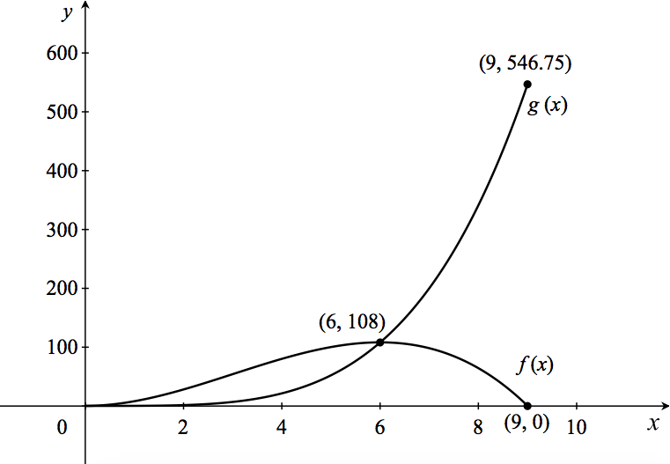 **2A**

**d.**  **1M**

  **1A**

**Question 5** (13 marks)

**a.** The turning point of *h*(*x*) occurs when *h*′(*x*) = 0. **1M**

*h*(*x*) = (*ex* – 3)2 – 4

*h*′(*x*) = 2*ex*(*ex* – 3)

*h*′(*x*) = 0 ⇒ 2*ex*(*ex* – 3) = 0

*ex* = 0 (undefined) or *ex* – 3 = 0

*ex* = 3

*x* = log*e*(3) **1A**



Turning point has coordinates *x* = log*e*(3) and *y* = −4 … as required **1A**

**b.** **i.** For *x* – intercept, let *y* = 0. **1M**

(*ex* – 3)2 – 4 = 0

(*ex* – 3)2 = 4 ⇒ *ex* – 3 = ± 2

*ex* = 5 or *ex* = 1

*x* = log*e*(5) or *x* = 0

The *x* intercepts are (log*e*(5), 0) and (0, 0). **1A**

**ii.** Using available CAS technology, calculate or . **1M**

Area = 12 – 5log*e*(5) **1A**

**c.** From the graph and **part a.**, *a* = log*e*(3). **1A**

**d.** Let *y* = (*ex* – 3)2 – 4

Interchange *x* and *y*: *x* = (*ey* – 3)2 – 4 **1M**

Make *y* the subject.

*x* + 4 = (*ey* – 3)2 … square root both sides of the equation (only the positive square root is needed)

 … add 3 to both sides of the equation

 … change from an exponential to a logarithm

 **1A**

**e.** The domain of *h*−1(*x*) is [−4, ∞) and the range of *h*−1(*x*) is [log*e*(3), ∞) **1A**

**f.** The intercept between *h*(*x*) and *h*−1(*x*) occurs when *h*(*x*) = *h*−1(*x*) = *x*.

Using available CAS technology, solve((*ex* – 3)2 – 4 = *x*)|1<*x*<2 ⇒ (1.68, 1.68).

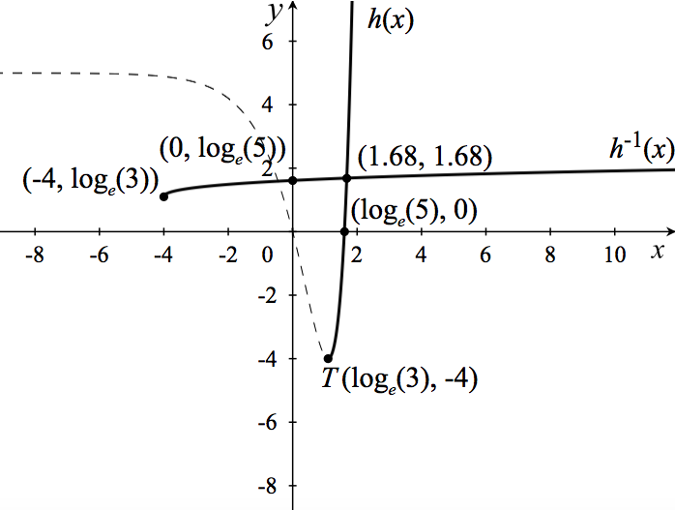 **2A**

**Question 6** (11 marks)

**a.** Horizontal translation of  units right. **1A**

**b.** Dilation of factor  from the *x* – axis and vertical translation of  units up. **1A**

**c.** The two functions have the same period, 2*π*. **1A**

The amplitude of *f* (*x*) is 1 and the amplitude of *g* (*x*) is . **1A**

**d.** The *y* – coordinate of point *A* is 0.

The *y* – coordinate of point *B* is .



 **1A**

**e.** At the points of intersection, *f* (*x*) = *g* (*x*).

Using available CAS technology, solve(, *x*) **1M**

*x* = 0.785398 or *x* = 3.28349

*f* (0.785398) = 0.71 and *f* (3.28349) = − 0.14

The two points of intersection are (0.79, 0.71) and (3.28, − 0.14) **1A**

**f.** Shaded area =  **1M**

Using available CAS technology, shaded area = 1.46562 ≈ 1.5 **1A**

**g.**  

  **1M**

 **1A**